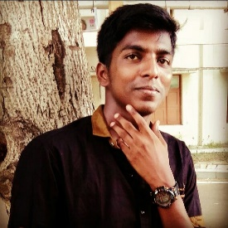

**SOFTWARE ENGINEER**

**GOWTHAMAN V**

 [gowthamanvai@gmail.com](mailto:gowthamanvai@gmail.com)  Bangalore

**HOBBIES**

**SKILLS**

**EDUCATION**

**EXPERIENCE **